UNIT 5
PROCESSOR
A processor (CPU) is the logic circuitry that responds to and processes the basic instructions that drive a computer. The CPU is seen as the main and most crucial integrated circuitry (IC) chip in a computer, as it is responsible for interpreting most of computers commands. Processor can manage all instructions such as arithmetical, logical, input/output (I/O) and other basic instructions, which are created by hardware or operating system. Its main job role is to obtain input from input devices and then produce the accurately result on the output devices.
The term processor is used interchangeably with the term central processing unit (CPU), although strictly speaking, the CPU is not the only processor in a computer. The GPU (graphics processing unit) is the most notable example, but the hard drive and other devices within a computer also perform some processing independently. Nevertheless, the term processor is generally understood to mean the CPU. Processors can be found in PCs, smartphones, tablets and other computers. The two main competitors in the processor market are Intel and AMD.

5.1 Introduce Hardwired and Micro Programmed.
Control unit:
To execute an instruction, the control unit of the CPU must generate the required control signal in the proper sequence. It directs the main operations by sending control signals to the data path. It flows between CPU, I/O, memory subsystem etc. There are two types (design) of control unit. They are:
- Hardwired control unit
- Micro programmed
The function of control unit are:
- It converts input information in to control signals.
- It control many execution units. (i.e. ALU, registers etc. ) contained within CPU.
- It also handles multiple tasks, such as fetching, decoding, execution handling and storing results.
- It controls data flow inside the processor.
Hardwired control unit
A hardwired control is a mechanism of producing control signals using Finite State Machines (FSM) appropriately. It is designed as a sequential logic circuit. The final circuit is constructed by physically connecting the components such as gates, flip flops, and drums. Hence, it is named a hardwired controller. Hardwired control unit is faster than the Micro programmed control unit. This architecture is preferred in RISC (Reduced Instruction Set Computer).
- A Hard-wired Control consists of two decoders, a sequence counter, and a number of logic gates.
- An instruction fetched from the memory unit is placed in the instruction register (IR).
- The component of an instruction register includes; I bit, the operation code, and bits 0 through 11.
- The operation code from bits 12 to 14 are coded with a 3 x 8 decoder.
- The outputs of the decoder are designated by the symbols D0 through D7.
- The operation code at bit 15 is transferred to a flip-flop designated by the symbol I.,
- The operation codes from Bits 0 through 11 are applied to the control logic gates.
- The Sequence counter (SC) can count in binary from 0 through 15.
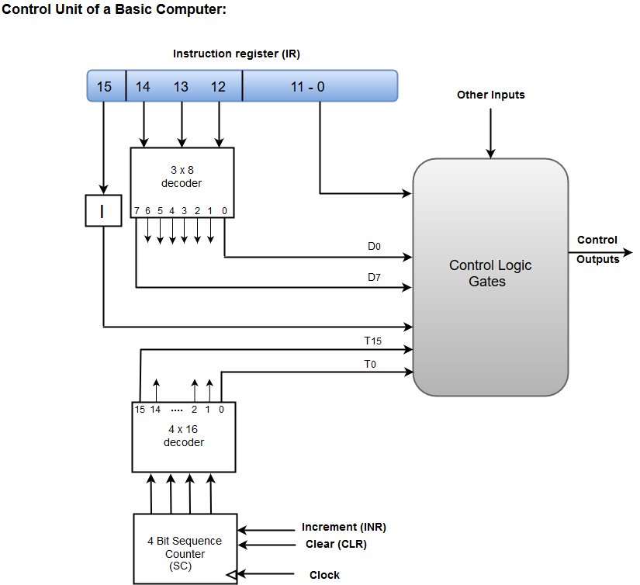
Advantages and disadvantages of Hardwired control unit
Advantages
- It depends on number of gates, how much delay can occur in generation of control signals.
- It can be optimized to produce the fast mode of operation.
- Faster than micro- programmed control unit.
Disadvantages
- The complexity of the design increases as we require more control signals to be generated (need of more encoders & decoders)
- Modifications in the control signals are very difficult because it requires rearranging of wires in the hardware circuit.
- Adding a new feature is difficult & complex.
- Difficult to test & correct mistakes in the original design.
Micro programmed
It is implemented using programming approach. A sequence of micro operations are carried out by executing a program consisting of micro instruction. Micro program consisting of micro instructions stored in the control memory (ROM) of the control unit. Execution of a micro instruction is responsible for generation of a set of control signal. This architecture is preferred in CISC.
Micro programmed consist of:
Control signals: they are group of bits. It is used to select the path in decoder, ALU and multiplexer.
Control word: It contain sequence of micro operation. After execution of control word it generate control signal.
Control memory: It is a memory containing control word (micro instruction).
Micro instruction: It contains control words stored in control memory. It specifies control signals for execution of micro operation.
Micro program: It is a sequence of micro instruction.
Architecture of micro programmed control unit
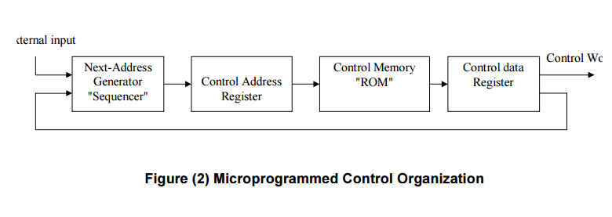

The address of micro-instruction that is to be executed is stored in the CAR (control address register).
Micro-instruction corresponding to the address stored in CAR is fetched from control memory and stored in the control data register.
This micro instruction contains control word to execute one or more micro operations.
After the execution of all micro operation of micro instruction the address of next micro instruction is located.
Advantages
- The micro programmed control unit is flexible in controlling the execution instruction.
- It can be modified easily as it is easy to change the code.
- It easily handles complex instructions also.
- The implementation of a micro programmed control unit is less costly.
Disadvantages
- The micro programmed control unit is slow as compared to the hardwired control unit.
- It is expensive than hardwired control unit.
TASK: difference between Micro programmed control unit and hardwired control unit.

5.2 Arithmetic and logical Unit
An arithmetic logic unit (ALU) is a digital circuit used to perform arithmetic and logic operations. It represents the fundamental building block of the central processing unit (CPU) of a computer. Modern CPUs contain very powerful and complex ALUs. In addition to ALUs, modern CPUs contain a control unit (CU).
Most of the operations of a CPU are performed by one or more ALUs, which load data from input registers. A register is a small amount of storage available as part of a CPU. The control unit tells the ALU what operation to perform on that data and the ALU stores the result in an output register. The control unit moves the data between these registers, the ALU, and memory.
How does ALU works?
Typically, the ALU has direct input and output access to the processor controller, main memory (random access memory or RAM in a personal computer) and input/output devices. Inputs and outputs flow along an electronic path that is called a bus. The input consists of an instruction word, sometimes called a machine instruction word that contains an operation code or "opcode," one or more operands and sometimes a format code. The operation code tells the ALU what operation to perform and the operands are used in the operation. For example, two operands might be added together or compared logically. The output consists of a result that is placed in a storage register and settings that indicate whether the operation was performed successfully. If it isn't, some sort of status will be stored in a permanent place that is sometimes called the machine status word. In general, the ALU includes storage places for input operands, operands that are being added, the accumulated result (stored in an accumulator) and shifted results. The flow of bits and the operations performed on them in the subunits of the ALU are controlled by gated circuits. In the arithmetic unit, multiplication and division are done by a series of adding or subtracting and shifting operations. In the logic unit, logic operations can be performed - such as comparing two operands and identifying where bits don't match. The design of the ALU is a critical part of the processor and new approaches to speeding up instruction handling are continually being developed.

5.3 Types of registers
In Computer Architecture, the Registers are very fast computer memory which are used to execute programs and operations efficiently. The register is utilized to acknowledge, store, move information and directions that are being utilized quickly by the CPU.
The sole purpose of having register is fast retrieval of data for processing by CPU. Though accessing instructions from RAM is comparatively faster with hard drive, it still isn’t enough for CPU. For even better processing, there are memories in CPU which can get data from RAM which are about to be executed earlier. After registers we have cache memory, which are faster but less faster than registers.
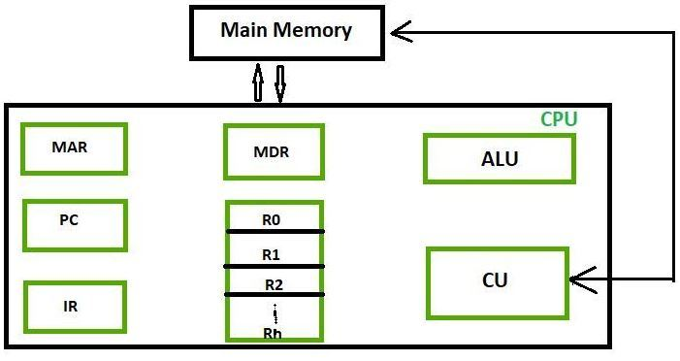
S.NO | NAME | SYMBOL | FUNCTIONING
1 | Accumulator | AC | An accumulator is the most often utilized register, and it is used to store information taken from memory.
2 | Memory address registers | MAR | Address location of memory is stored in this register to be accessed later. It is called by both MAR and MDR together
3 | Memory data registers | MDR | All the information that is supposed to be written or the information that is supposed to be read from a certain memory address is stored here
4 | General-purpose register | GPR | Consist of a series of registers generally starting from R0 and running till Rn - 1. These registers tend to store any form of temporary data that is sent to a register during any undertaking process.  More GPR enables the register to register addressing, which increases processing speed.
5 | Program counter | PC | These registers consist of the memory address of the next instruction to be fetched. PC points to the address of the next instruction to be fetched from the main memory when the previous instruction has been completed successfully. Program Counter (PC) also functions to count the number of instructions.  The increment of PC depends on the type of architecture being used. If we use a 32-bit architecture, the PC gets incremented by 4 every time to fetch the next instruction.
6 | Instructions registers | IR | Instruction registers hold the information about to be executed. The immediate instructions received from the system are fetched and stored in these registers.  Once the instructions are stored in registers, the processor starts executing the set instructions, and the PC will point to the next instructions to be executed
7 | Condition code registers |  | These have different flags that represent the status of operations. These registers set the flags accordingly if the result of operation caused zero or negative
8 | Temporary registers | TR | Holds temporary data
9 | Input registers | INPR | Carries input character
10 | Output registers | OUTR | Carries output character
11 | Index registers | BX | We use this register to store values and numbers included in the address information and transform them into effective addresses. These are also called base registers.  These are used to change operand address at the time of execution, also stated as BX
12 | Memory buffer register | MBR | MBR - Memory buffer registers are used to store data content or memory commands used to write on the disk. The basic functionality of these is to save called data from memory. It is used to transfer data from main memory to CPU or Vice versa.  MBR is very similar to MDR
13 | Stack control registers | SCR | Stack is a set of location memory where data is stored and retrieved in a certain order. Also called last in first out ( LIFO ), we can only retrieve a stack at the second position only after retrieving out the first one, and stack control registers are mainly used to manage the stacks in the computer.
14 | Flag register | FR | Flag registers are used to indicate a particular condition. Each registered flag defines a condition or a flag.  The data that is stored is split into 8 separate bits.  Basic flag registers -  Zero flags  Carry flag  Parity flag  Sign flag  Overflow flag.
15 | Segment register | SR | Hold address for memory
16 | Data register | DX | Hold memory operand

5.4 Instruction Execution
Instruction is command which is given by the user to computer. Execution is the process by which a computer performs instruction. Instruction execution means a program to be executed by a processor consists of a set of instructions stored in memory.
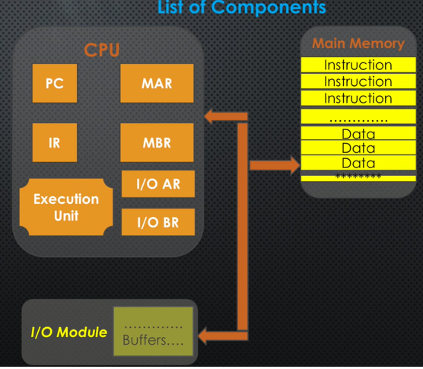
Fig: list of component in instruction execution
Process in instruction execution
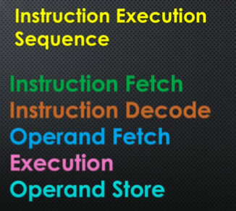
  - Instruction fetch
During the instruction fetch, the PC (program counter) has address value of instruction. The instruction value is transferred to the MAR. According to the value in MAR the address location in main memory is identified. In that memory location the instruction is there. That instruction is transfer to MBR. After that, from the MBR the instruction is transferred to the IR. So, this is how instruction is fetch to IR.
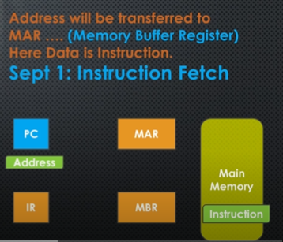
  - Instruction decode
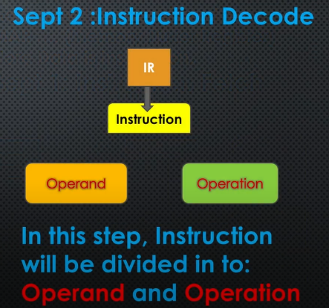
Here, instruction is decoded and divided into two major component i.e. operand and operation. The operand tells address of data and operation tells which operation to be performed.
  - operand fetch
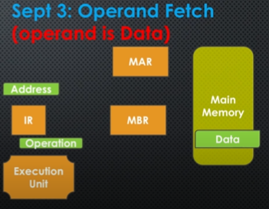
During the operand fetch, the operation is transferred to execution unit, for that operation we need the operand. The IR contain address of operand. First the address in IR is passed to MAR. From the MAR the memory location of data in main memory is identified. Now, the data from main memory is transferred to MBR. From the MBR the data is transferred to execution unit.
  - Execution
Now, execution unit has two things i.e. data and operation. Now, both data and operation is processed. After the execution of instruction output is produced by execution unit which is again the operand or data, that needed to be stored in memory.
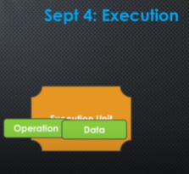
Operand store:
5th step or last step is operand store. The output (operand) generated by execution unit, operand is stored in main memory. To store operand, address calculation is performed. Memory address is identified by MAR. Now, output (operand) is stored in that identified address in a main memory.
So, this is how whole instruction execution is performed step by step.
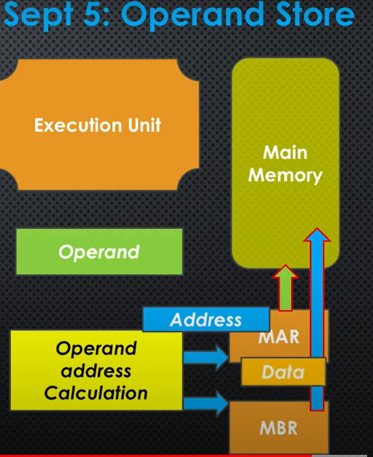

5.5 Bus architecture
In computer system all the peripherals are connected to microprocessor through Bus. Bus is a group of wires that connects different components of the computer. It is used for transmitting data, control signal and memory address from one component to another. A bus can be 8 bit, 16 bit, 32 bit and 64 bit. A 32 bit bus can transmit 32 bit information at a time. A bus can be internal or external.
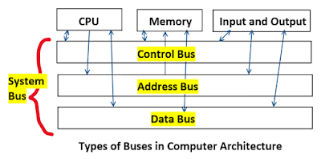
Types of Bus structure:
- Address bus
- Data bus
- Control bus

1. Address Bus:
Address bus carries memory address. A memory address is a numerical value used for identifying a memory location. Computer performs all its task through the memory address. CU of CPU sends memory address to all the components. So, address bus is also uni-directional from CPU to all other components.

2. Data Bus:
- Data bus carry the data.
- Data bus is a bidirectional bus.
- Data bus fetch the instructions from memory.
- Data bus used to store the result of an instruction into memory.
- Data bus carry commands to an I/O device controller or port.
- Data bus carry data from a device controller or port.
.
3.Control Bus:
Control bus carries control signal. CU of CPU uses control signal for controlling all the components. It is uni-directional from CPU to all other components.

Different types of control signals are used in a bus:
Memory Read: This signal, is issued by the CPU or DMA (Direct memory access) controller when performing a read operation with the memory.
Memory write: This signal is issued by the CPU or DMA controller when performing a write operation with the memory.
I/O Read: This signal is issued by the CPU when it is reading from an input port.
I/O Write: This signal is issued by the CPU when writing into an output port.

5.6 Addressing modes
The addressing mode is the method to specify the operand of an instruction. The job of a microprocessor is to execute a set of instructions stored in memory to perform a specific task. Operations require the following:
- The operator or opcode which determines what will be done
- The operands which define the data to be used in the operation
For example, if we wanted to add the numbers 1 and 2 and get a result, mathematically we would likely write this as 1 + 2. In this case, our operator is (+), or the addition, and our operands are the numbers 1 and 2.
In a microprocessor, the machine needs to be told how to get the operands to perform the operation. The effective address is a term that describes the address of an operand that is stored in memory. There are several methods to designate the effective address of those operands or get them directly from the register. These methods are known as addressing modes. In this lesson, we're going to define several addressing modes that can be used to indicate how to retrieve operands. We'll also illustrate examples of how each addressing mode is used and point out some characteristics of these addressing modes.
Different types of address mode are:
- Immediate addressing
- Direct addressing
- Register addressing
- Register indirect addressing
- Index addressing
- Based index addressing
Immediate addressing
In immediate addressing mode the source operand is always data. If the data is 8-bit, then the instruction will be of 2 bytes, if the data is of 16-bit then the instruction will be of 3 bytes. No memory reference is required to fetch data. So no additional calculations are required to work out the effective address. It is a fast method. But the downside is that it has a limited range.
Example: ADD 5 (here, 5 is data)
MVI B 45 (move the data 45H immediately to register B)
Direct addressing
When using direct addressing mode, the address of the operand is specified in the instruction. The processor will retrieve the data directly from the address specified in the instruction. The example shows how the instruction tells the processor where to get the data from in memory.
Examples:
LDA 9500H (loads the content of memory location 9500H directly into accumulator)
Add R1, (1001) (Add the content of R1 and 1001 and store back to R1, Here 1001 is the address where data/operand is stored.)
Register addressing
Register addressing mode indicates the operand data is stored in the register itself, so the instruction contains the address of the register. The data would be retrieved from the register. Retrieving data from the register is fast and the instructions are shorter because no memory is involved. The operation is performed within various registers of the microprocessor.
Examples:
MOV A, B (move the contents of register B to register A)
ADD A, B (add contents of registers A and B and store the result in register A)
INR A (increment the contents of register A by one)
Register indirect addressing
In this addressing mode, the address field of the instruction refers to a CPU register that contains the effective address of the operand. Register indirect addressing mode also used to call as indirect addressing mode.
Example:
MOV AX, [BX] (move the contents of memory locations addressed by the register BX to the register AX)
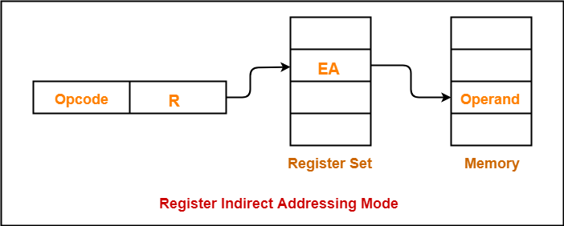

Difference between register indirect addressing and register direct addressing
REGISTER MODE | REGISTER INDIRECT MODE
Operand is placed in general purpose register. | Operand’s offset is placed in one of the registers.
In register mode, address field contains the effective address of operand. | In register indirect mode, address field contains reference of effective address.
It requires only one register reference to access data. | It requires two register references to access data.
No further calculation is required to perform the operation. | Require further calculation to find the effective address.
Register addressing mode is fast. | Register indirect addressing mode is slow.
It is easier to access the data in register mode. | It is a bit complex to access the data in register indirect mode.
It uses temporary variables. | It uses pointers.
Index addressing
It is used to access or implement array efficiently. Multiple register required to implement. Any element can accessed without changing instruction. In index addressing mode, contents of Index register is added to address part of instruction to obtain effective address (EA). The address part of instruction holds the beginning/base address and is called as base. The index register hold the index value, which is +ve. Base remains same, the index changes. When the base is added to the index register the resultant number is the memory location where the operand will be placed.
NOTE: Effective address: the address where the actual operand/data is present.
The EA is the sum of the content of an index register SI or DI and an 8 bit or 16 bit displacement.
EA= base address +IX (index)
Example:
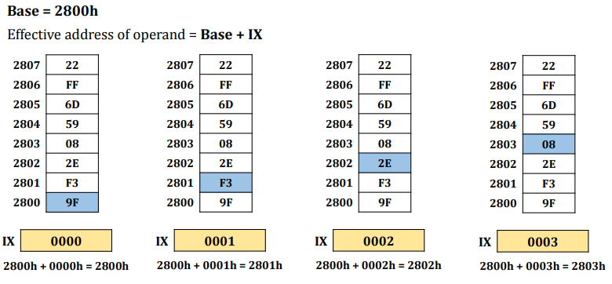

Based index addressing
In base register addressing mode, contents of base register is added to address part of instruction to obtain effective address. Here, the base register hold the beginning/base address. The address part of instruction holds the offset. Offset remains same, the base changes. When the offset is added to the base register the resultant number is the memory location where the operand will be placed.
The Effective address of operand is sum of the content of a base register BX or BP and an index register SI or DI (offset).
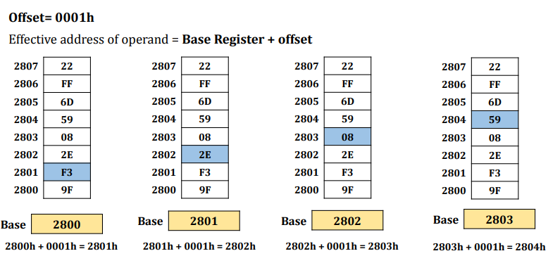

5.7 Types of processor
A microprocessor is basically the brain of the computer. We can also call it simply a processor or CPU. Furthermore, a microprocessor is basically a computer processor that is mounted on a single IC (Integrated Circuit). It means that all the functions of the processor are included on a single chip. Furthermore, the basic task of a microprocessor is to input the instructions from the memory, decode, and process them and produce the output. It performs three basic tasks while processing the information.
We have three basic types of microprocessors. They are as follows:
- CISC
- RISC
- EPIC (explicitly parallel instruction computer)
CISC (Complex Instruction Set Computer)
CISC stands for “Complex Instruction Set Computer”. CISC has to contain the complex instructions set, and due to that reason CISC take couple of time for executing all instructions, hence its speed more slow to RISC. As the name suggests, the instructions are in a complex form. It means that a single instruction can contain many low-level instructions. For example loading data from memory, storing data to the memory, performing basic operations, etc. Besides, we can say that a single instruction has multiple addressing modes. Furthermore, as there are many operations in single instruction they use very few registers.
Examples of CISC are Intel 386, Intel 486, Pentium, Pentium Pro, Pentium II, etc.
RISC (Reduced Instruction Set Computer)
RISC means to “Reduced Instruction Set Computer”. Main objective of designing RISC is to decrease execution time that is simplified by the computer’s instructions. RISC has to use just one clock cycle for producing the result on uniform execution time. As per the name, in this, the instructions are quite simple, and hence, they execute quickly. Moreover, the instructions get complete in one clock cycle and also use a few addressing modes only. Besides, it makes use of multiple registers so that interaction with memory is less.
Examples are IBM RS6000, DEC Alpha 21064, DEC Alpha 21164, etc.
Characteristics of CISC are as follows:
- As the instructions are complex hence, the decoding of instructions is also complex.
- The size of instructions is greater than the one-word size.
- Instruction can take more than one clock cycle to execute.
- The number of registers is less since most of the operations are performed in memory itself.
- The address modes are also complex.
- Data types are more in number.
Characteristics of RISC are as follows:
- As the instruction is simple hence, the decoding of instructions is also simple.
- The size of instructions is under the one-word size.
- Instruction takes one clock cycle to execute.
- The number of registers is more.
- The address modes are also simple.
- Data types are less in number.
- Can be used for pipelining. (Pipelining organizes the execution of the multiple instructions simultaneously. Pipelining improves the throughput of the system)
Advantages of CISC are as follows:
- Microprogramming in CISC is as easy as the assembly language implementation.
- The number of instructions for performing operations is less in number. Hence, the memory usage is low. Moreover, time consumption is also less.
Advantages of RISC are as follows:
- Instructions are simple hence easy to understand and decode.
- The instructions complete in one clock cycle therefore, CPU can handle multiple instructions at a time.
- Designing the RISC processors is easier in comparison to the CISC processors.
The differences between CISC and RISC are as follows:
RISC | CISC
- It focuses on the software. | - It focuses on the hardware.
- Uses the hardwired control unit. | - It uses a hardwired as well as a microprogrammed control unit.
- Uses transistors for more registers. | - Transistors are used for storing the complex instructions.
- The instructions have a fixed size. | - The size of instructions vary.
- It performs only register to register arithmetic operations. | - Besides the register to register operations, it can also perform register to memory or memory to register operations.
- Fewer registers are used. | - It requires more number of registers.
- As the instructions are individual the code is large. | - Multiple operations are present in single instruction hence, the code is small.
- Executes in one clock cycle. | - Takes more than one clock cycle for execution.
- Instructions have a size of one word. | - The size of instructions is greater than the one-word size.
- Examples are IBM RS6000, DEC Alpha 21064, DEC Alpha 21164, etc. | - Examples of CISC are Intel 386, Intel 486, Pentium, Pentium Pro, Pentium II, etc.

